- Login on https://ocs.springer.com/ocs/home/COMS2 using your user id and password.
- Click on paper list tab as shown below.
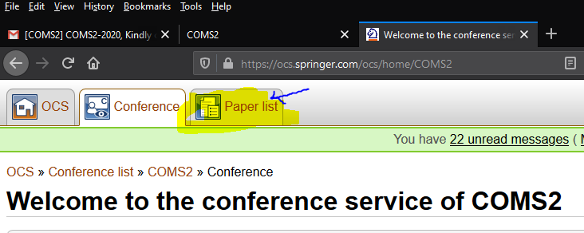

- Click on your selected paper title.
- At the end of page click on Final Upload.
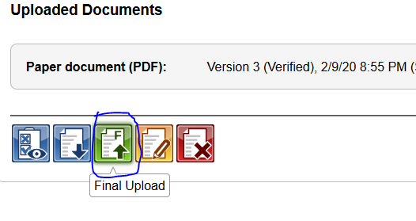
- At the end of page, upload your final paper and high quality images (.zip). Also download Copyright Form Draft file take printout, fill it, select filed file and click on upload button to submit your final document version.
